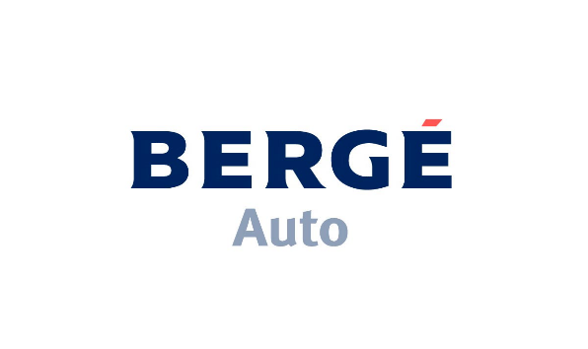

**Press Announcement**

November 3rd , 2021

___________________________________________________________________________________________

**Bergé Auto appointed Aiways exclusive distributor for Switzerland  
  
Aiways U5 SUV pre-launch during Auto Zürich from 4 till 7 November.**

Bergé Auto becomes the exclusive distributor for Aiways in Switzerland. As a pre-launch event, the Shanghai based EV brand will be the surprise of the Zürich motorshow, opening November 4th.

Bergé Auto will handle this operation through its subsidiary Alcomotive (a joint venture between Bergé Auto and the Belgian based Alcopa).

**The Aiways story**

With a mission to solve the mobility challenges of tomorrow and drive forward a progressive development in the automotive industry, Aiways was founded as a start-up in 2017 by the Chinese entrepreneurs Samuel Fu and Gary Gu.

The development of the first model, the U5 SUV, started with a blank sheet of paper and the desire to make electric driving as enjoyable, exciting and affordable as possible. A few short years later, the global Aiways network comprises a highly innovative, digitalized plant in Shangrao (China) with an annual capacity of more than 300,000 vehicles, an R&D center and a design center in Shanghai (China), a battery factory in Changshu (China) and the overseas Headquarter in Munich (Germany).

At the company’s headquarters in Shanghai, a team of experienced engineers, technical specialists, designers and industrial experts work with top-class partners along the entire supply chain. Today, from their base in Germany, Aiways is working on the expansion of the brand throughout Europe and a lot of other overseas markets.

**The Aiways U5 SUV in the spotlights**

During Auto Zürich, Bergé Auto will present the U5 SUV to the Swiss audience. The Aiways U5 SV leaves nothing to be desired and leaves no room for compromise. That’s because this full electric SUV peerlessly combines an outstanding range of +400 km (WLTP) with plenty of space, a minimalistic design language with impressive features, and innovative technologies with straightforward handling. Thanks to the fast-charging capabilities, the U5 SUV charges from 20 to 80% in only 35 minutes.

With the Aiways U5 SUV, you will reach your destination both comfortably and cost-effectively. The fully batterie-electric U5 SUV with 204 hp delivers driving pleasure from start to finish, wherever the destination. At the Zürich Motorshow, both specifications will be shown. With a very attractive pricing position, the U5 SUV is an unbeatable offer in the SUV EV segment.

In 2022, the Shanghai based brand will launch the fully batterie-electric U6 Coupé-SUV.

**Proud distributor**

**Olivier Sermeus,** Alcomotive COO, commented:

“We are honored and proud to add Aiways to our brand portfolio. With our distribution experience in Switzerland we aim to establish an extensive Aiways dealer network and we are confident to make a success of the brand in the Swiss market.”

**Dr. Alexander Klose**, Executive Vice President of Overseas Operations at Aiways, commented:

“We’ve had our eye on the Swiss market for a while now, and we’re delighted to partner with Bergé Auto. Our exciting products and their proven track record in sales and marketing will give us the best chance of attracting new EV buyers to the Aiways brand. Also, our European expansion is with the 2022 start in Switzerland in full swing and there are more markets to come – even this year.”

[**www.bergeauto.com**](http://www.bergeauto.com)

[**www.ai-ways.eu**](http://www.ai-ways.eu)

[**www.alcomotive.com**](http://www.alcomotive.com)